

|  |
| --- |
| CS 1103 – FR02B  Assignment 1 |
| Ngoc Phuong Anh Nguyen - 2712361  January 2021 |

# **Chapter One Questions:**

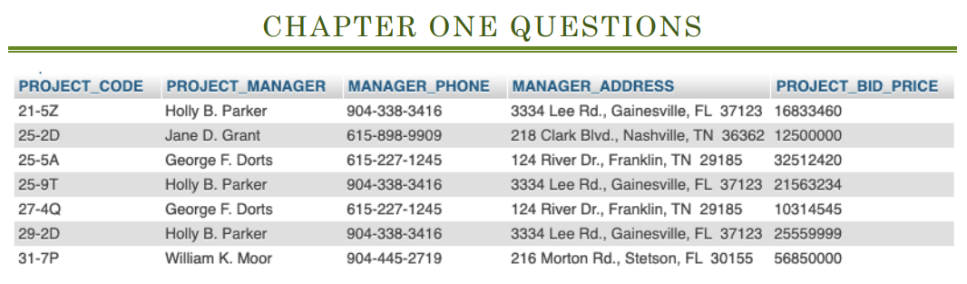

Figure 1: Chapter One

## Question 1: How many records does the file contain? How many fields are there per record?

* There are 7 records.
* Each record has 5 fields.

## Question 2: What problem would you encounter if you wished to produce a listing ordered by the manager’s last name? How could you alter the file structure to solve this problem?

* Because the manager’s name is referenced in the completely full name, it is difficult to create a list sorted by the manager’s last name.
* To solve this problem, we should split PROJECT_MANAGER into 2 or 3 fields:
  + MANAGER_FIRST_NAME and MANAGER_LAST_NAME, or
  + MANAGER_FIRST_NAME, MANAGER_MIDDLE_NAME, MANAGER_LAST_NAME

## Question 3: Knowing that users would need reports for particular states, area codes or zip-codes (postal codes), how would you (re)structure the file?

In order to restructure the file with states, area codes and zip-codes separately, we must divide the MANAGER_ADDRESS into 4 (MANAGER_ADDRESS, MANAGER_STATE, MANAGER_AREA_CODE, MANAGER_ZIP_CODE.

## Question 4: Identify and discuss the serious data redundancy problems in the file structure.

The information of Holly B. Parker and William K. Moor is stored in the file many times. Although each of them works on various projects within different bid prices and codes, storing the repetitive information in just one file is unnecessary. My solution is to give each project manager a unique ID, then create 2 tables: one that displays their information and the other shows their projects. It prevents their information from being changed many times.

# Chapter Two Questions:

## Review Question 2: What is a business rule, and what is its purpose in data modelling?

A business rule is a brief, precise, and unambiguous description of a policy, procedure, or principle within a specific organization.

Properly written business rules are used to define entities, attributes, relationships, and constraints.

## Review Question 11: What is a relationship, and what three types of relationships exist?

* A relationship is an association among entities.
* Three types of relationships:
  + One-to-many (:M OR 1..*)
  + Many-to-many (M:N or *..*)
  + One-to-one (1:1 OR 1..1)

## Review Question 12: Give an example of each of the three types of relationships.

### Type 1: One-to-many

There are two entities type “Person” and “Phone Number”. Each “Phone Number” belongs to only one “Person”, and each “Person” can have more than one “Phone Number”. Therefore, this is a one-to-many relationship.

### Type 2: Many-to-many:

There are two entities “Customer” and “Product”. A customer can purchase various products, and product can be purchased by many customers. Therefore, this is a many-to-many relationship.

### Type 3: One-to-one

There are two entities “Student” and “Student ID”. A “Student” can only have one “Student ID”, and each “Student ID” only belongs to one “Student”. Therefore, this is a one-to-one relationship.

## Problem 14: Create a Crow’s Foot ERD to include the following business rules for the ProdCo company:

### a. Each sales representative writes many invoices.

### b. Each invoice is written by one sales representative.

### c. Each sales representative is assigned to one department.

### d. Each department has many sales representatives.

### e. Each customer can generate many invoices.

### f. Each invoice is generated by one customer.

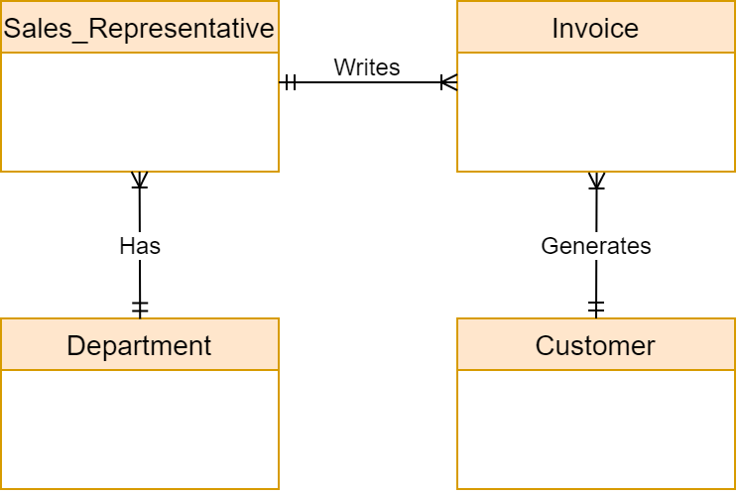

Figure 2: Crow's Foot ERD of ProdCo company

## Problem 16: Create a Crow’s Foot ERD for each of the following descriptions. (Note that the word *many* merely means *more than one* in the database modeling environment.)

### c. An airliner can be assigned to fly many flights, but each flight is flown by only one airliner.

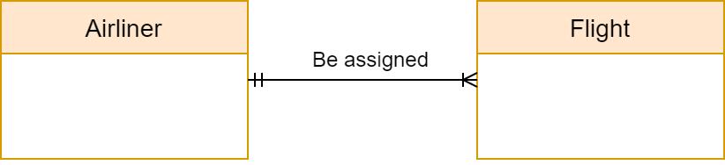

Figure 3: Crow's Foot ERD of Airliner and Flight

### d. The KwikTite Corporation operates many factories. Each factory is located in a region, and each region can be “home” to many of KwikTite’s factories. Each factory has many employees, but each employee is employed by only one factory.

Figure 4: Crow's Foot ERD of KwikTite Corporation